LAB 3: DESIGN SPRINT EXPERIMENT REPORT

Topic: Electricity Outage Information Is Not Communicated Clearly

Name: Alfred Antony

Roll No: 24BTCE225

1. Aim of the Experiment
The aim of this experiment is to apply the Design Sprint / Design Thinking methodology by following the stages Empathize, Define, Ideate, Prototype, and Test to design a user-centered solution for people who face difficulty in receiving clear and timely electricity outage information.
The focus is on understanding real user problems and validating solutions through feedback, rather than making assumptions.

2. Problem Context
Electricity outages occur frequently due to maintenance, overload, weather conditions, or technical faults.
However, outage information is often:
- Communicated late or not at all
- Shared through unclear messages
- Available only on websites or offices difficult to access
- Missing restoration time estimates
Because of this, users experience:
- Frustration and uncertainty
- Difficulty planning daily activities
- Problems for students, workers, and businesses
- Lack of trust in electricity service providers

3. Empathize Stage

Objective
To deeply understand the needs, emotions, behaviors, and frustrations of users during electricity outages.

Activities Performed
- Reviewed observations and notes from earlier labs
- Spoke with household users, students, and shop owners
- Observed reactions when power suddenly went off
- Checked how users try to find outage information

Key Observations
- Users search multiple sources (neighbors, WhatsApp, websites).
- No clear restoration time is provided.
- Messages from electricity boards are technical and confusing.
- Users feel helpless and irritated.

Empathy Map Summary

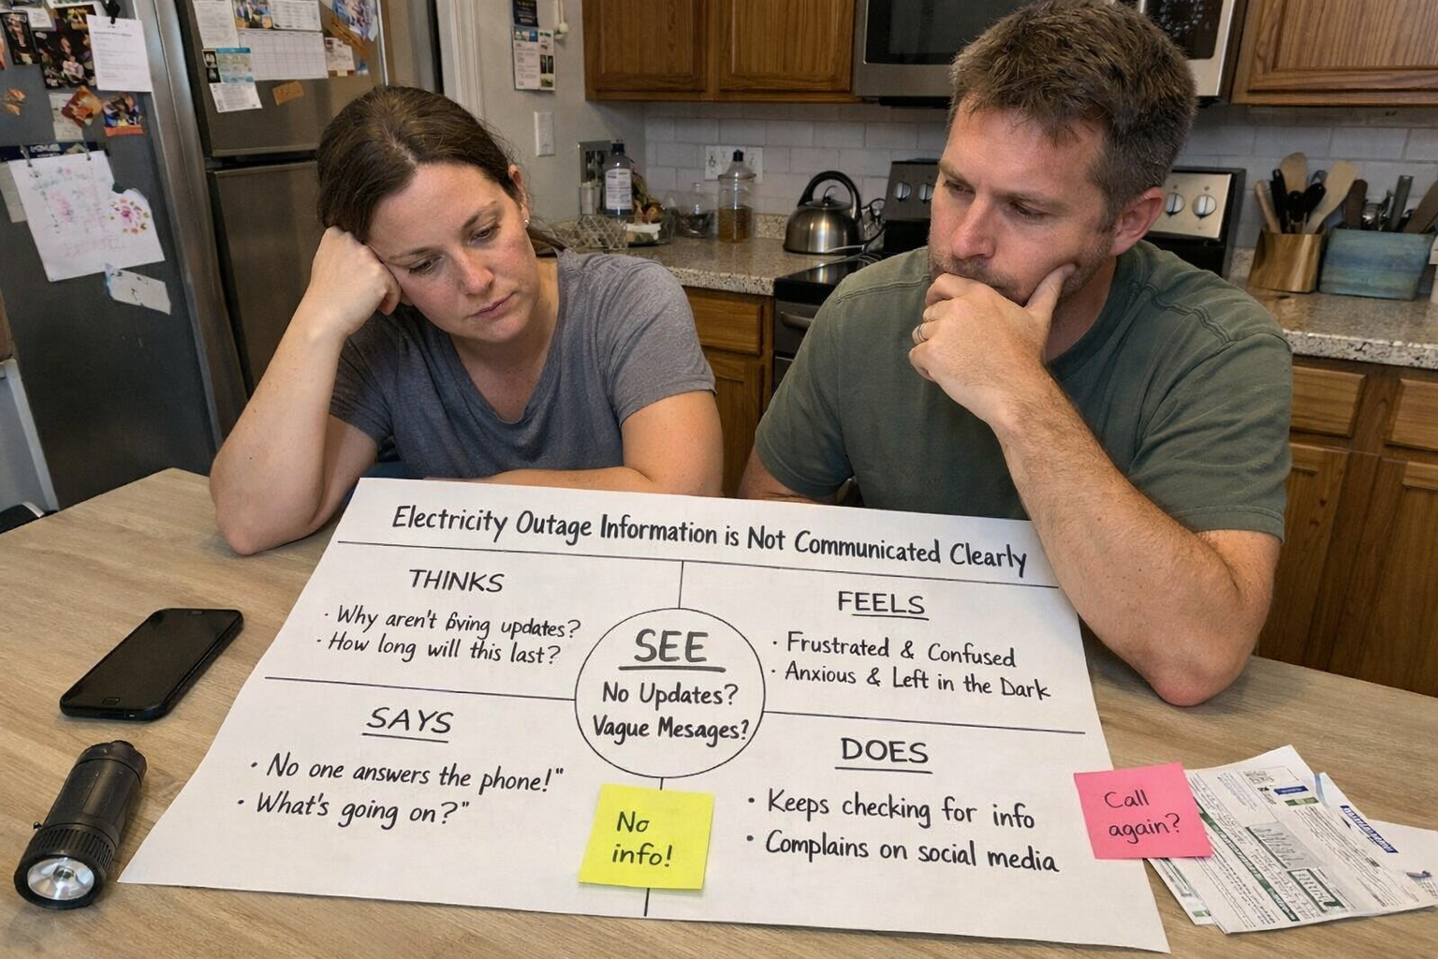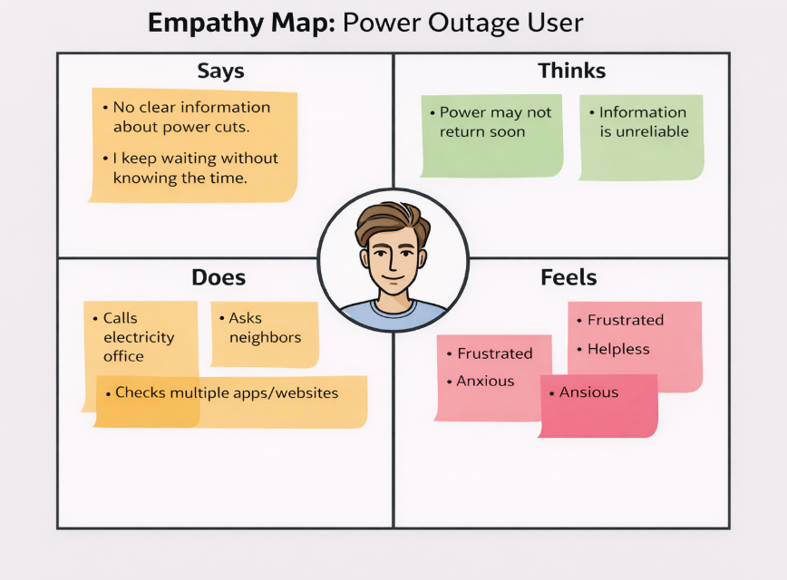

User Insight
Users do not only need electricity; they need clear, timely, and understandable outage communication to plan their activities confidently.

4. Define Stage

Objective
To convert user insights into a clear and actionable problem statement.

Problem Statement
Residents need a simple and reliable way to receive clear electricity outage information because the current communication is unclear, delayed, or unavailable, causing frustration and poor planning.

How Might We (HMW) Question
How might we provide residents with clear, real-time, and easy-to-understand electricity outage information so they can plan their daily activities confidently?

5. Ideate Stage

Objective
To generate multiple possible solutions without early judgment.

Brainstormed Ideas
- Mobile app with real-time outage alerts
- SMS notification system for all registered users
- Map showing affected areas and restoration time
- Voice call alert for elderly users
- WhatsApp automatic outage chatbot
- Color-coded power status indicator (Green/Red)
- Option to report local outage quickly
- Estimated countdown timer for restoration

Idea Selection
Selected Solution:
A Real-Time Electricity Outage Information Mobile System with:
- Instant alerts
- Clear restoration time
- Simple language
- Area-wise status map
Justification:
- High user value
- Technically feasible
- Easy to understand and use
- Works for large population

6. Prototype Stage

Objective
To build a low-fidelity, testable prototype of the selected solution.

Prototype Description
The prototype includes simple wireframe screens:
- Home Screen
  - Current power status
  - “Report Outage” button
  - Area selection
- Outage Alert Screen
  - Cause of outage
  - Start time
  - Expected restoration time
  - Simple icons and colors
- Map View
  - Highlighted affected areas
  - Estimated repair progress
- Notification Screen
  - SMS / app alert preview

Design Rationale
- Simple layout reduces confusion
- Color indicators improve quick understanding
- Time estimate reduces anxiety
- Notifications prevent repeated searching

Prototype Type
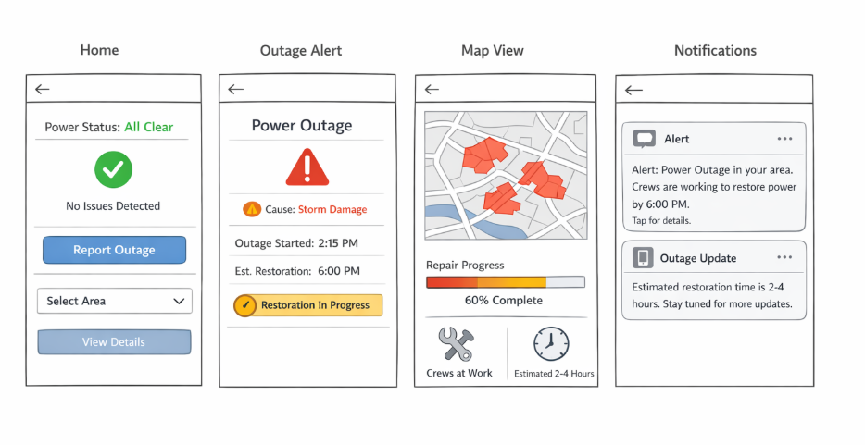

7. Test Stage

Objective
To evaluate the prototype using real user interaction and feedback.

Testing Method
- Showed prototype to two residents and one shop owner
- Asked them to check outage status and restoration time
- Observed behavior and recorded feedback

User Feedback Summary
What Worked Well
- Easy to see outage information quickly
- Restoration time was very helpful
- Map view improved area understanding
What Was Confusing
- Some icons needed clear labels
- Users wanted regional language support

User Suggestions
- Add voice announcement
- Provide offline SMS alerts
- Show repair progress percentage

Observation
Users felt more confident and less frustrated compared to the current real-life situation.

8. Iteration and Improvements
Based on testing:
- Add regional language options
- Improve icon clarity with text labels
- Include voice and SMS alerts
- Provide live repair progress tracking

9. Reflection
This experiment showed that the real issue was not only power failure, but poor communication.
Initial assumptions focused on technical outage problems, but user feedback revealed the major pain point was lack of clear information.
Key learnings:
- Empathy is critical in system design
- Small features like time estimate and alerts greatly reduce stress
- User testing changes design direction
- Communication design is as important as technical infrastructure

10. Conclusion
The Design Sprint process successfully helped identify and solve a real user communication problem related to electricity outages.
Through empathy, ideation, prototyping, and testing, a user-friendly outage information system was proposed.

